**UNIT 2**

**Optical Sources**

Optical transmitter coverts electrical input signal into corresponding optical signal. The optical signal is then launched into the fiber. Optical source is the major component in an optical transmitter. Popularly used optical transmitters are Light Emitting Diode (LED) and semiconductor Laser Diodes (LD).

**Characteristics of Light Source of Communication**

To be useful in an optical link, a light source needs the following characteristics:

i) It must be possible to operate the device continuously at a variety of temperatures for many years.

ii) It must be possible to modulate the light output over a wide range of modulating frequencies. iii) For fiber links, the wavelength of the output should coincide with one of transmission windows for the fiber type used.

iv) To couple large amount of power into an optical fiber, the emitting area should be small.

v) To reduce material dispersion in an optical fiber link, the output spectrum should be narrow.

vi) The power requirement for its operation must be low.

vii) The light source must be compatible with the modern solid state devices.

viii) The optical output power must be directly modulated by varying the input current to the device.

ix) Better linearity of prevent harmonics and intermodulation distortion.

x) High coupling efficiency.

xi) High optical output power.

xii) High reliability.

xiii) Low weight and low cost.

Two types of light sources used in fiber optics are light emitting diodes (LEDs) and laser diodes (LDs).

**Origins of Laser Noise**

The origins of laser noise can be divided into two groups:

* [*quantum noise*](https://www.rp-photonics.com/quantum_noise.html), in particular associated with [spontaneous emission](https://www.rp-photonics.com/spontaneous_emission.html) in the [gain medium](https://www.rp-photonics.com/laser_gain_media.html)
* *technical noise*, arising e.g. from excess noise of the pump source, from vibrations of the laser resonator, or from temperature fluctuations

Impacts of Laser Noise

Laser noise is important for many [laser applications](https://www.rp-photonics.com/laser_applications.html). Some examples are:

* High precision optical measurements, e.g. in [frequency metrology](https://www.rp-photonics.com/frequency_metrology.html), precision [laser spectroscopy](https://www.rp-photonics.com/laser_spectroscopy.html) or [interferometry](https://www.rp-photonics.com/interferometers.html" \o "optical devices utilizing the phenomenon of interference), require low intensity and [phase noise](https://www.rp-photonics.com/phase_noise.html).
* The data transmission rates achievable with [optical fiber communications](https://www.rp-photonics.com/optical_fiber_communications.html) systems are usually limited by noise of lasers and [amplifiers](https://www.rp-photonics.com/amplifier_noise.html).
* For precise [laser material processing](https://www.rp-photonics.com/laser_material_processing.html), it is often necessary that beam pointing fluctuations and pulse energy variations are minimized.

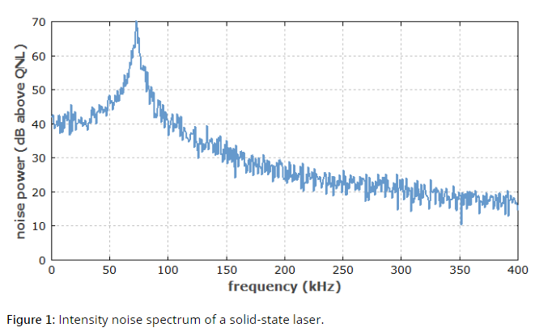

Methods for Noise Reduction

Laser noise can be reduced in many ways:

* Quantum noise can be reduced e.g. by increasing the intracavity power level, by minimizing optical losses and by increasing the resonator length.
* Technical noise influences can be reduced, e.g. by building a stable laser resonator, by temperature stabilization of the setup, or by using a low-noise pump source.
* Laser parameters can be optimized so that the laser reacts less strongly to certain noise influences.
* [Mode hopping](https://www.rp-photonics.com/mode_hopping.html) may be suppressed, e.g. with an [optical filter](https://www.rp-photonics.com/optical_filters.html).
* There are various active or passive techniques for the [stabilization of lasers](https://www.rp-photonics.com/stabilization_of_lasers.html).

A prerequisite for effective noise reduction is that the origin of the most disturbing noise is known, in addition to the parameters determining the laser's sensitivity to thus noise influences. Depending on the case, it can be more effective to reduce either noise influences themselves or the laser's sensitivity.

**Phase noise**

In [signal processing](https://en.wikipedia.org/wiki/Signal_processing), phase noise is the [frequency-domain](https://en.wikipedia.org/wiki/Frequency-domain) representation of random fluctuations in the [phase](https://en.wikipedia.org/wiki/Phase_(waves)) of a [waveform](https://en.wikipedia.org/wiki/Waveform), corresponding to [time-domain](https://en.wikipedia.org/wiki/Time-domain) deviations from perfect periodicity ([jitter](https://en.wikipedia.org/wiki/Jitter)). Generally speaking, [radio-frequency](https://en.wikipedia.org/wiki/Radio-frequency) engineers speak of the phase noise of an [oscillator](https://en.wikipedia.org/wiki/Oscillator), whereas [digital-system](https://en.wikipedia.org/wiki/Digital-system) engineers work with the jitter of a clock.

Historically there have been two conflicting yet widely used definitions for phase noise. Some authors define phase noise to be the [spectral density](https://en.wikipedia.org/wiki/Spectral_density) of a signal's phase only, while the other definition refers to the phase spectrum (which [pairs up with the amplitude spectrum](https://en.wikipedia.org/wiki/Spectral_density#Related_concepts)) resulting from the [spectral estimation](https://en.wikipedia.org/wiki/Spectral_estimation) of the signal itself. Both definitions yield the same result at offset frequencies well removed from the carrier. At close-in offsets however, the two definitions differ.

**Effect of Noise on BER of BPSK, QPSK, DPSK, and QAM Modulation Techniques**

INTRODUCTION

In digital modulation, digital symbols are converted into waveforms that are compatible with the characteristics of the channel. Bandpass modulation is a process by which the information signal is converted to sinusoidal waveform for digital modulation. Coherent and non-coherent modulation/demodulation is the basic types of bandpass modulation. Binary Phase Shift Keying (BPSK), Quadrature Phase Shift Keying (QPSK), and Quadrature Amplitude Modulation (QAM) are specialized formats of these techniques [3]. In an ideal channel the transmitted signal from the transmitter will pass through channel upto the receiver, where it is demodulated to get a perfect representation of the original signal. However in reality the received signal consists of mixture of attenuated and reflected version of the transmitted signal [2]. In addition to these, the channel adds various types of noise to the signal. This affects the Bit Error rate of the system.

2. BIT ERROR RATE

The quality of transmission is decided by parameter, Signal to Noise ratio (SNR) in analog and by Bit Error Rate (BER) in digital In digital communication, the ratio Eb/No, a normalized version of SNR as a figure of merit is used. Eb is bit energy and can be described as signal power S times the bit time Tb. N0 is noise power spectral density and can be described as noise power (N) divide by bandwidth (W). Since bit time and bit rate Rb are reciprocal, we can replace Tb with 1/Rb.



In Digital communication the number of bit errors is the number of received bits of a data stream over a communication channel that has been altered due to noise, interference, distortion or bit synchronization errors. The bit error rate or bit error ratio (BER) is the number of bits in error divided by the total number of transferred bits during a studied time interval. BER is a unit less performance measure; often expressed as a percentage. The performance of each modulation technique is measured by calculating the BER in presence of different types of noise.

3. DIGITAL MODULATION SCHEMES

A digital signal can modulate amplitude, frequency, or phase of sinusoidal carrier wave. If the modulating waveform consists of NRZ rectangular pulses, then the modulated parameter will be switched or keyed from one discrete value to another. This results into three basic types of digital modulation schemes namely Amplitude Shift Keying (ASK), Frequency Shift Keying (FSK), and Phase Shift Keying (PSK) [4].

This paper deals with the types of PSK viz. BPSK, DPSK, QPSK and QAM. This section will describe these methods in detail.

1. *BPSK:* In BPSK, the carrier gets 0 or 180o phase shift corresponding to two different voltage levels of binary modulating signal. If the sinusoid is of amplitude A, it has a power  so that  The transmitted signal is given by

**

Where b(t) is a stream of binary digits with voltage levels [6][7].

1. *DPSK:* DPSK is a modification of BPSK which eliminates the ambiguity about whether the demodulated data is or is not inverted. It is a type of non-coherent detection. The term differential

encoding refers to the procedure of encoding the data differentially i.e. the presence of binary 1 or 0 is manifested by the symbol’s similarity or difference when compared with the preceding symbol.



1. *QPSK:* When a data is transmitted using BPSK technique the channel bandwidth required is *2fb*. The QPSK technique reduces that bandwidth to *fb.* It is a multilevel phase modulation. In this two successive bits in a bit stream are combined together to form a message and each message is represented by distinct value of phase shift of a carrier. The QPSK signal is represented as. Since there are 4 phases it is called as 4-PSK or Quadrature PSK systems [6][7].



1. *QAM:* QAM improves the noise immunity of the system by allowing the signal vectors to differ, not only in their phase but also in amplitudes. It utilizes carrier phase shifting and synchronous detection to permit two DSB signals to occupy the same frequency band. The two DSB signals are orthogonal to each other.
2. NOISE AND CHANNELS IN COMMUNICATION SYSTEMS
   1. *Noise in Communication Systems*

The term noise refers to unwanted electrical signals that are always present in electrical systems. The presence of noise superimposed on a signal tends to obscure or mask the signal; limits the receiver’s ability to mask correct symbol decisions, and thereby limits the rate of information transmission [2].

Contaminating noise in signal transmission usually has an additive effect in the sense that noise often adds to the information-bearing signal at various points between the source and the destination. For the purpose of analysis, all the noise will be lumped into one source added to the signal in the AWGN channel. So, in this paper, effect of various noise on BER of different modulation schemes have been studied. The various sources of noise used for this system are mentioned below:

1. *Gaussian Noise*: Various types of noise sources are gaussian and have a flat spectral density over a wide frequency range. Such a spectrum has all frequency components in equal proportion and is therefore called white gaussian noise otherwise it is non-white gaussian noise. The gaussian noise generator block used, generates discrete time white gaussian noise.
2. *Rayleigh Noise:* In digital communication, we are interested in the two dimensional noise distributed around each state in the phase plane. The noise can be characterized in two ways. A three dimensional picture is given by the product of two orthogonal gaussian distributions with the same standard deviation. Alternately, with the polar coordinates centered on the undeviated position of the state, the radial distribution of the noise is described by the Rayleigh distribution. The Rayleigh noise generator block used, generates Rayleigh distributed noise.
3. *Rician Noise*: Unlike additive Gaussian noise, Rician noise is signal-dependent and consequently separating signal from noise is a difficult task. Rician noise is problematic for low signal-to-noise ratio.

# Comparing BPSK, QPSK, 4PAM, 16QAM, 16PSK, 64QAM and 32PSK

I have written another article in [DSPDesginLine.com](http://www.dspdesignline.com/howto/208801783;jsessionid=KQBZX4ZJRFCX0QSNDLRSKHSCJUNN2JVN). This article can be treated as the third post in the series aimed at understanding Shannon’s capacity equation.

For the first two posts in the series are:

1. [Understanding Shannon’s capacity equation](http://www.dsplog.com/2008/06/15/shannon-gaussian-channel-capacity-equation/)

2. [Bounds on Communication based on Shannon’s capacity](http://www.dsplog.com/2008/07/2008/06/18/bounds-on-communication-shannon-capacity/)

The article summarizes the **symbol error rate derivations** in **AWGN** for modulation schemes like **BPSK**, **QPSK**, **4PAM**, **16QAM**, **16PSK**, **64QAM** and **32PSK**.

The article in [DSPDesignline.com](http://www.dspdesignline.com/howto/208801783;jsessionid=KQBZX4ZJRFCX0QSNDLRSKHSCJUNN2JVN?pgno=1) details the following:

* Based on the knowledge of **bandwidth requirements** for each type of modulation scheme, the **capacity** in bits/seconds/Hz is listed.
* Using the knowledge that the symbol to noise ratio http://www.dsplog.com/cgi-bin/mimetex.cgi?%5Cfrac%7BE_s%7D%7BN_0%7D is http://www.dsplog.com/cgi-bin/mimetex.cgi?k=%5Clog_2%28M%29 times the bit to noise ratio http://www.dsplog.com/cgi-bin/mimetex.cgi?%5Cfrac%7BE_b%7D%7BN_0%7D, the symbol error rate vs http://www.dsplog.com/cgi-bin/mimetex.cgi?%5Cfrac%7BE_b%7D%7BN_0%7D curves are plotted.
* Using symbol error rate versus http://www.dsplog.com/cgi-bin/mimetex.cgi?%5Cfrac%7BE_b%7D%7BN_0%7D plots, the http://www.dsplog.com/cgi-bin/mimetex.cgi?%5Cfrac%7BE_b%7D%7BN_0%7D required for achieving symbol error rate of http://www.dsplog.com/cgi-bin/mimetex.cgi?10%5e%7b-5%7dis identified.
* Upon having the capacity and http://www.dsplog.com/cgi-bin/mimetex.cgi?%5Cfrac%7BE_b%7D%7BN_0%7D requirement, the requirements for **BPSK**, **QPSK**, **4PAM**, **16QAM**, **16PSK**, **64QAM** and **32PSK** are [mapped on to the Shannon’s capacity vs Eb/No curve](http://www.dspdesignline.com/howto/208801783;jsessionid=KQBZX4ZJRFCX0QSNDLRSKHSCJUNN2JVN?pgno=3).
* Assuming **Gray coded modulation mapping**, each symbol error causes one bit out of http://www.dsplog.com/cgi-bin/mimetex.cgi?k=%5Clog_2%28M%29 bits to be in error. So, the relation between symbol error and bit error is,http://www.dsplog.com/cgi-bin/mimetex.cgi?P_b%20%5Capprox%20%5Cfrac%7BPs%7D%7Bk%7D.
* Using this assumption, the **Bit Error Rate (BER)** for **BPSK**, **QPSK**, **4PAM**, **16QAM, 16PSK**, **64QAM** and **32PSK** are listed and the **BER vs Eb/No curve** plotted.

**Digital Phase Modulation: BPSK, QPSK, DQPSK**

Digital phase modulation is a versatile and widely used method of wirelessly transferring digital data.

In the previous page, we saw that we can use discrete variations in a carrier’s amplitude or frequency as a way of representing ones and zeros. It should come as no surprise that we can also represent digital data using phase; this technique is called phase shift keying (PSK).

**Binary Phase Shift Keying (BPSK)**

The most straightforward type of PSK is called binary phase shift keying (BPSK), where “binary” refers to the use of two phase offsets (one for logic high, one for logic low).

We can intuitively recognize that the system will be more robust if there is greater separation between these two phases—of course it would be difficult for a receiver to distinguish between a symbol with a phase offset of 90° and a symbol with a phase offset of 91°. We only have 360° of phase to work with, so the maximum difference between the logic-high and logic-low phases is 180°. But we know that shifting a sinusoid by 180° is the same as inverting it; thus, we can think of BPSK as simply inverting the carrier in response to one logic state and leaving it alone in response to the other logic state.

To take this a step further, we know that multiplying a sinusoid by negative one is the same as inverting it. This leads to the possibility of implementing BPSK using the following basic hardware configuration:

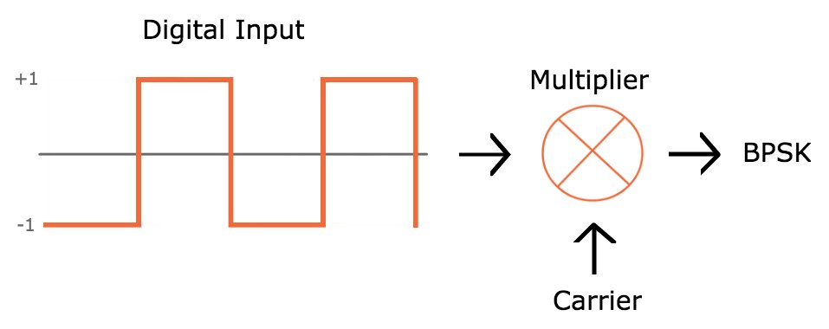

However, this scheme could easily result in high-slope transitions in the carrier waveform: if the transition between logic states occurs when the carrier is at its maximum value, the carrier voltage has to rapidly move to the minimum voltage.

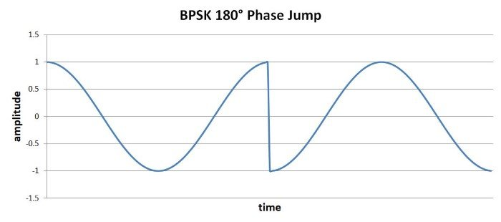

High-slope events such as these are undesirable because they generate higher-frequency energy that could interfere with other RF signals. Also, amplifiers have limited ability to produce high-slope changes in output voltage.

If we refine the above implementation with two additional features, we can ensure smooth transitions between symbols. First, we need to ensure that the digital bit period is equal to one or more complete carrier cycles. Second, we need to synchronize the digital transitions with the carrier waveform. With these improvements, we could design the system such that the 180° phase change occurs when the carrier signal is at (or very near) the zero-crossing.

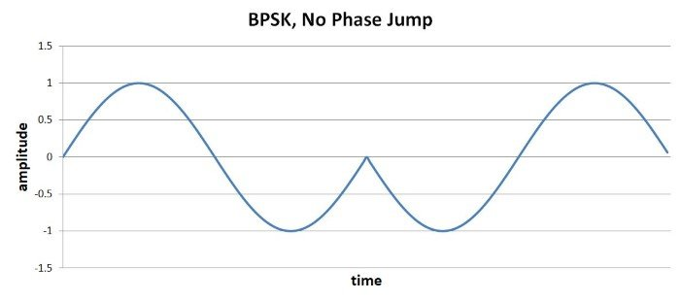

**QPSK**

BPSK transfers one bit per symbol, which is what we’re accustomed to so far. Everything we’ve discussed with regard to digital modulation has assumed that the carrier signal is modified according to whether a digital voltage is logic low or logic high, and the receiver constructs digital data by interpreting each symbol as either a 0 or a 1.

Before we discuss quadrature phase shift keying (QPSK), we need to introduce the following important concept: There is no reason why one symbol can transfer only one bit. It’s true that the world of digital electronics is built around circuitry in which the voltage is at one extreme or the other, such that the voltage always represents one digital bit. But RF is not digital; rather, we’re using *analog* waveforms to transfer *digital* data, and it is perfectly acceptable to design a system in which the analog waveforms are encoded and interpreted in a way that allows one symbol to represent two (or more) bits.

QPSK is a modulation scheme that allows one symbol to transfer two bits of data. There are four possible two-bit numbers (00, 01, 10, 11), and consequently we need four phase offsets. Again, we want maximum separation between the phase options, which in this case is 90°.

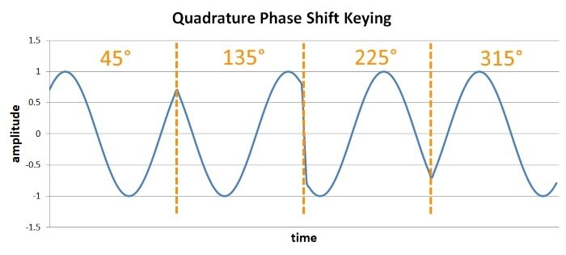

The advantage is higher data rate: if we maintain the same symbol period, we can double the rate at which data is moved from transmitter to receiver. The downside is system complexity. (You might think that QPSK is also significantly more susceptible to bit errors than BPSK, since there is less separation between the possible phase values. This is a reasonable assumption, but if you go through the math it turns out that the error probabilities are actually very similar.)

**Variants**

QPSK is, overall, an effective modulation scheme. But it can be improved.

**Phase Jumps**

Standard QPSK guarantees that high-slope symbol-to-symbol transitions will occur; because the phase jumps can be ±90°, we can’t use the approach described for the 180° phase jumps produced by BPSK modulation.

This problem can be mitigated by using one of two QPSK variants. Offset QPSK, which involves adding a delay to one of two digital data streams used in the modulation process, reduces the maximum phase jump to 90°. Another option is π/4-QPSK, which reduces the maximum phase jump to 135°. Offset QPSK is thus superior with respect to reducing phase discontinuities, but π/4-QPSK is advantageous because it is compatible with differential encoding (discussed in the next subsection).

Another way to deal with symbol-to-symbol discontinuities is to implement additional signal processing that creates smoother transitions between symbols. This approach is incorporated into a modulation scheme called minimum shift keying (MSK), and there is also an improvement on MSK known as Gaussian MSK.

**Differential Encoding**

Another difficulty is that demodulation with PSK waveforms is more difficult than with FSK waveforms. Frequency is “absolute” in the sense that frequency changes can always be interpreted by analyzing the signal variations with respect to time. Phase, however, is relative in the sense that it has no universal reference—the transmitter generates the phase variations with reference to a point in time, and the receiver might interpret the phase variations with reference to a separate point in time.

The practical manifestation of this is the following: If there are differences between the phase (or frequency) of the oscillators used for modulation and demodulation, PSK becomes unreliable. And we have to assume that there will be phase differences (unless the receiver incorporates carrier-recovery circuitry).

Differential QPSK (DQPSK) is a variant that is compatible with noncoherent receivers (i.e., receivers that don’t synchronize the demodulation oscillator with the modulation oscillator). Differential QPSK encodes data by producing a certain phase shift *relative to the preceding symbol*. By using the phase of the preceding symbol in this way, the demodulation circuitry analyzes the phase of a symbol using a reference that is common to the receiver and the transmitter.

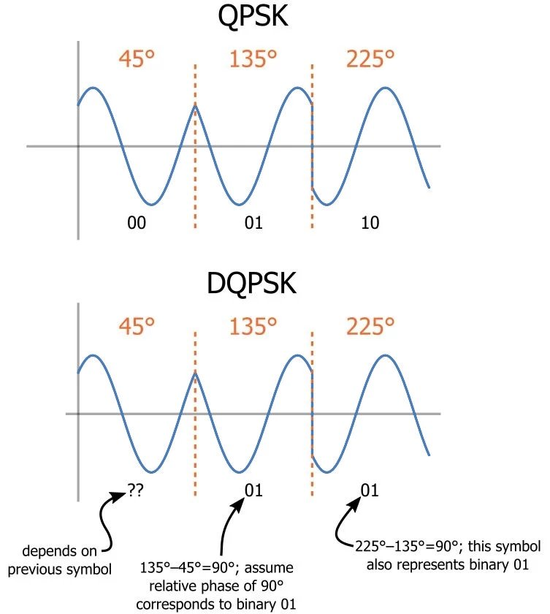

**Summary**

* Binary phase shift keying is a straightforward modulation scheme that can transfer one bit per symbol.
* Quadrature phase shift keying is more complex but doubles the data rate (or achieves the same data rate with half the bandwidth).
* Offset QPSK, π/4-QPSK, and minimum shift keying are modulation schemes that mitigate the effects of high-slope symbol-to-symbol voltage changes.
* Differential QPSK uses the phase difference between adjacent symbols to avoid problems associated with a lack of phase synchronization between the transmitter and receiver.

**Attenuation and Dispersion in Fiber-Optic Cable**

Correct functioning of an optical data link depends on modulated light reaching the receiver with enough power to be demodulated correctly. *Attenuation* is the reduction in power of the light signal as it is transmitted. Attenuation is caused by passive media components such as cables, cable splices, and connectors. Although attenuation is significantly lower for optical fiber than for other media, it still occurs in both multimode and single-mode transmission. An efficient optical data link must have enough light available to overcome attenuation.

*Dispersion* is the spreading of the signal over time. The following two types of dispersion can affect an optical data link:

* Chromatic dispersion—Spreading of the signal over time, resulting from the different speeds of light rays.
* Modal dispersion—Spreading of the signal over time, resulting from the different propagation modes in the fiber.

For multimode transmission, modal dispersion—rather than chromatic dispersion or attenuation—usually limits the maximum bit rate and link length. For single-mode transmission, modal dispersion is not a factor. However, at higher bit rates and over longer distances, chromatic dispersion rather than modal dispersion limits maximum link length.

**Dispersion in Optical Fibers**

There are three types of dispersion: modal, chromatic, and material.

**Modal Dispersion**

Modal dispersion refers to the path taken by a ray of light. Many transmitters emit multiple mode types. Some of the light rays travel through the fiber while others reflect off of the fiber core’s boundary, instead traveling along an indirect path on the waveguide. These constitute the two types of modes: high-order modes and low-order modes.

* **High-order modes** enter the fiber at acute or obtuse angles, and take significantly longer to pass through fiber than low-order modes.
* **Low-order modes**enter the fiber directly and pass through it more quickly.

Modal dispersion can be eliminated by using a single-mode fiber. These fibers only transmit one mode of light, so the signal won’t be spread through modal dispersion.

**Chromatic Dispersion**

Chromatic dispersion results from the emitter’s spectral width, which determines the number of wavelengths that are emitted—the smaller the spectral width, the fewer wavelengths. Longer wavelengths move faster than shorter ones, so they arrive at the end of the fiber quicker to spread out the signal. Chromatic dispersion may be decreased by narrowing the transmitter’s spectral width. A monochromatic emitter has just a single wavelength, so it does not contribute to chromatic dispersion.

Chromatic dispersion is important to [researchers who design optical equipment](https://www.swiftglass.com/industries/optical/), including cameras, optical microscopes, and telescopes. The system in such equipment must be carefully planned—which includes using a combination of lenses made of different materials with different indices of refraction—so that the chromatic aberrations are minimized, resulting in an optimal image.

**Material Dispersion**

Material dispersion occurs when the wavelength depends on the refractive index of the fiber core material. Material dispersion is a contributing factor to a number of phenomena, including:

* Waveguide delay dispersion
* Chromatic aberrations in lenses
* Group delay distortion
* Color separation in prisms
* Multimode group delay spread
* Differential mode delay

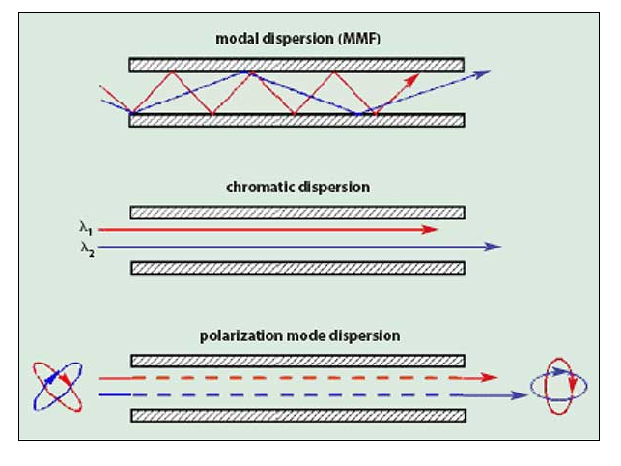

**B-V Curves**

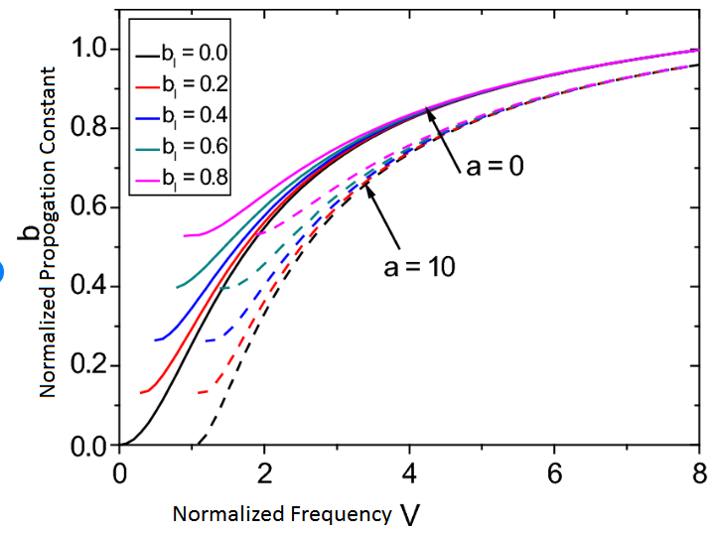

Three-layer slab waveguide with a graded-index film and a nonlinear substrate is investigated. The nonlinear substrate is considered of Kerr-type and the film index is assumed to change linearly as we move from the film-clad to the film-substrate interfaces. The solutions of the fields in the guiding film contains Airy functions which can be write..